**Mac Operating System**

Every Mac comes with a collection of great apps for things you do every day, like Safari for surﬁng the web, Photos for managing your photos and videos, Pages for creating documents, Numbers for making spreadsheets and Keynote for preparing presentations. There are apps for sending email and text messages, taking notes, and staying up to date with your contacts and calendar. It even comes with the Mac App Store for finding new apps. Your Mac is more than fully featured, it’s fully loaded.



The Photos app for Mac makes it simple to manage a lifetime’s worth of photos and videos. Powerful yet easy-to-use editing tools let you edit like a pro even if you’re a beginner. And you can add to your toolkit with editing extensions from your favourite developers and access them within the Photos app. Photos has also been fine-tuned to make it even easier to manage your library. Now you can add a location to a single image or a group of photos, and you can batch change photo titles, descriptions and keywords. Naming your favourite people in Faces is faster with a streamlined workflow. And you can sort your albums — and the contents inside them — by date, title and more.



Turn 4K video into movie magic: Browse your clips easily, instantly share your favourite moments, and create Hollywood‑style trailers and beautiful movies at stunning 4K resolution. You can even start editing on iPhone or iPad, and finish on a Mac.

* Browse The home of home video: If you have an iPhone or iPad, not to mention a camcorder or digital camera, you probably have a lot of great video. View all your photos and video clips in the redesigned Media browser and when inspiration strikes, easily turn them into the next great movie or trailer.
* Make movies Rated S for simple: It’s never been easier to make it in the movies. Just choose the clips you want to use. Insert titles, add effects and create a full soundtrack with powerful tools that are as simple as drag and drop. iMovie even supports 4K video for stunning cinema-quality films. And that, ladies and gentlemen, is a wrap.
* iMovie everywhere Start on your iPhone. Then cut to your Mac: iMovie for Mac and iMovie for iOS are designed to work together. So now you can start a project on your iPhone, continue working on your iPad, and then add the final touches on your Mac. And with iMovie Theater, all your finished movies and trailers appear on all your devices. So you’ll always be the star of the show.
* Share Lights. Camera. Reaction: What’s a film without an audience? iMovie gives you even more ways to share with your most loyal fans. Post it on the web for everyone to see. Or email it to a select crowd. Get your movie out there, then sit back and take all the credit.



Make insightful — and beautiful — spreadsheets with Numbers. Drop your data into one of many stunning, Apple-designed templates. Easily add your own images, text and shapes to the flexible, free-form canvas. Create some quick calculations with the help of the formula panel. Then visualise the numbers with a dramatic interactive chart that animates your data.



Make insightful — and beautiful — spreadsheets with Numbers. Drop your data into one of many stunning, Apple-designed templates. Easily add your own images, text and shapes to the flexible, free-form canvas. Create some quick calculations with the help of the formula panel. Then visualise the numbers with a dramatic interactive chart that animates your data.



## The smartest way to surf.Safari is the best, fastest and most secure way to surf the web on your Mac, with all kinds of innovative features that make your browsing more enjoyable. Keep favourite websites open and accessible with Pinned Sites. Quickly mute audio without hunting for the tab it’s coming from. And use AirPlay to stream video from a web page to your HDTV with Apple TV. It’s also easy to share the cool pages you find. Just click the Share button to tweet, post to Facebook or send to a friend. Energy-saving technologies let you surf longer. And built-in privacy features protect you from being tracked as you go.



Disk Utility is the name of a utility, created by Apple, for performing disk-related tasks in Mac OS X. These tasks include:

* The creation, conversion, compression and encryption of disk images from a wide range of formats read by Disk Utility to .dmg or .cdr, which is identical to the .iso format
* Mounting, unmounting, and ejecting disks (including both hard disks, removable media and disk images)
* Enabling or disabling journaling
* Verifying a disk's integrity, and repairing it if the disk is damaged
* Verifying and repairing permissions
* Disk erasing, formatting and partitioning
* Secure deletion of free space or disk using a 35-pass Gutmann algorithm
* Adding or changing partition table between Apple Partition Table and GUID Partition Table
* Creating, destroying, and repairing RAID sets
* Restoring volumes from scanned for ASR images
* Burning disk images to CD or DVD in HFS+ format
* Erasing CD-RWs and DVD-RWs
* Checking the S.M.A.R.T status of a hard disk



The Finder is the app that helps you navigate all of the files and folders on your Mac. The Finder lets you browse your apps, disks, files, and folders in a variety of ways. You can use the Finder to organize these items the way you want. You can also use the Finder to search for items, delete files you no longer want, and more.



Back up using Time Machine. After you [set up Time Machine](https://support.apple.com/en-in/HT201250#setup), it automatically makes hourly backups for the past 24 hours, daily backups for the past month, and weekly backups for all previous months. The oldest backups are deleted when your backup drive is full.

* To back up now instead of waiting for the next automatic backup, choose Back Up Now from the Time Machine menu .
* To stop automatic backups, turn off Time Machine in Time Machine preferences. You can still back up manually by choosing Back Up Now from the Time Machine menu.
* To pause a backup, choose Stop Backup from the Time Machine menu. To resume, choose Back Up Now.
* To check backup status, use the Time Machine menu. The icon shows when Time Machine is backing up, idle until the next automatic backup, or unable to complete the backup.
* To exclude items from your backup, open Time Machine preferences from the Time machine menu, click Options, then click Add and select the item to exclude.

 **Search**

## Search with Spotlight. Use Spotlight to search for things like apps, documents, images and other files. In OS X Yosemite, Spotlight suggestions offer additional results like Wikipedia, news sites, Maps, iTunes, movie listings, and more.To open Spotlight, click the magnifying glass icon in the upper-right corner of the menu bar, or press Command-Space from any app.

Spotlight appears front and center when you open it. To search for something, type words related to it like an app name, a word contained in a document, or [a tag](http://support.apple.com/kb/HT202754) you've attached to a file. You can also search for items like a Wikipedia article, or the location of your nearest Apple Store.



The Dock holds your favorite apps, documents, and more. The Dock is a convenient place to access the apps you use the most. The Dock is the bar of icons that sits at the bottom or side of your screen. It provides easy access to many of the apps that come with your Mac (like [Mail](http://support.apple.com/kb/HT5361), [Safari](http://support.apple.com/kb/HT6074), and [Messages](http://support.apple.com/kb/HT5395)). You can add your own apps, documents and folders to the Dock, too.

## Organizing the Dock

## 

The Dock keeps apps on its left side. Folders, documents, and minimized windows are kept on the right side of the Dock. If you look closely, you can see a vertical separator line that separates these two sides.If you want to rearrange where an icon appears on the Dock, just drag it to another location in the Doc



# If you can‘t unlock the Security & Privacy pane, make sure you‘ve set an admin password. You can't use admin accounts with blank passwords to unlock the Security & Privacy pane of System Preferences. You can't unlock the Security & Privacy pane if the admin account you're using has a blank password.

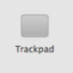

Use Multi-Touch gestures on your Mac. With a Multi-Touch trackpad or Magic Mouse, you can tap, swipe, pinch, or spread one or more fingers to perform useful actions.

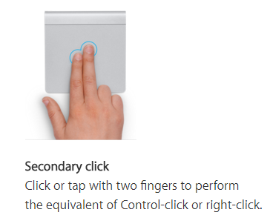

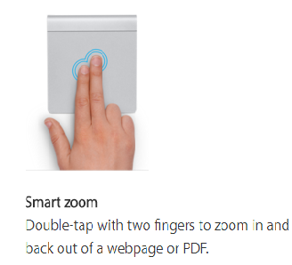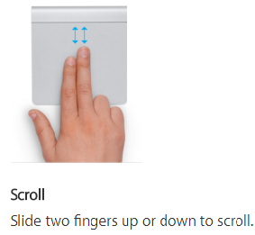

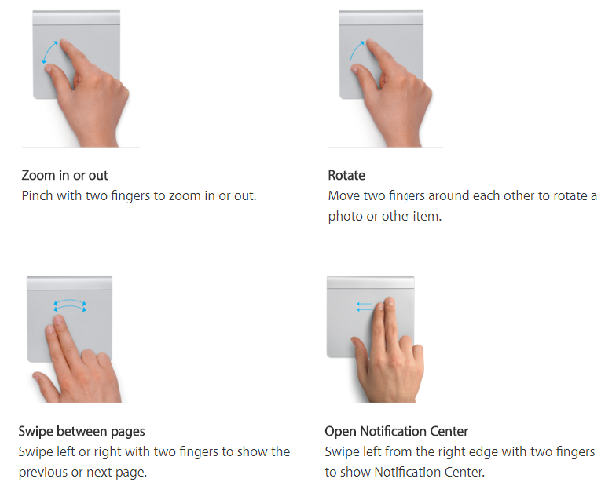



Using Parental Controls preferences, People can manage, monitor, and control the time their kids spend on the Mac, the websites they visit, and the people they chat with.